Curriculum Vitae
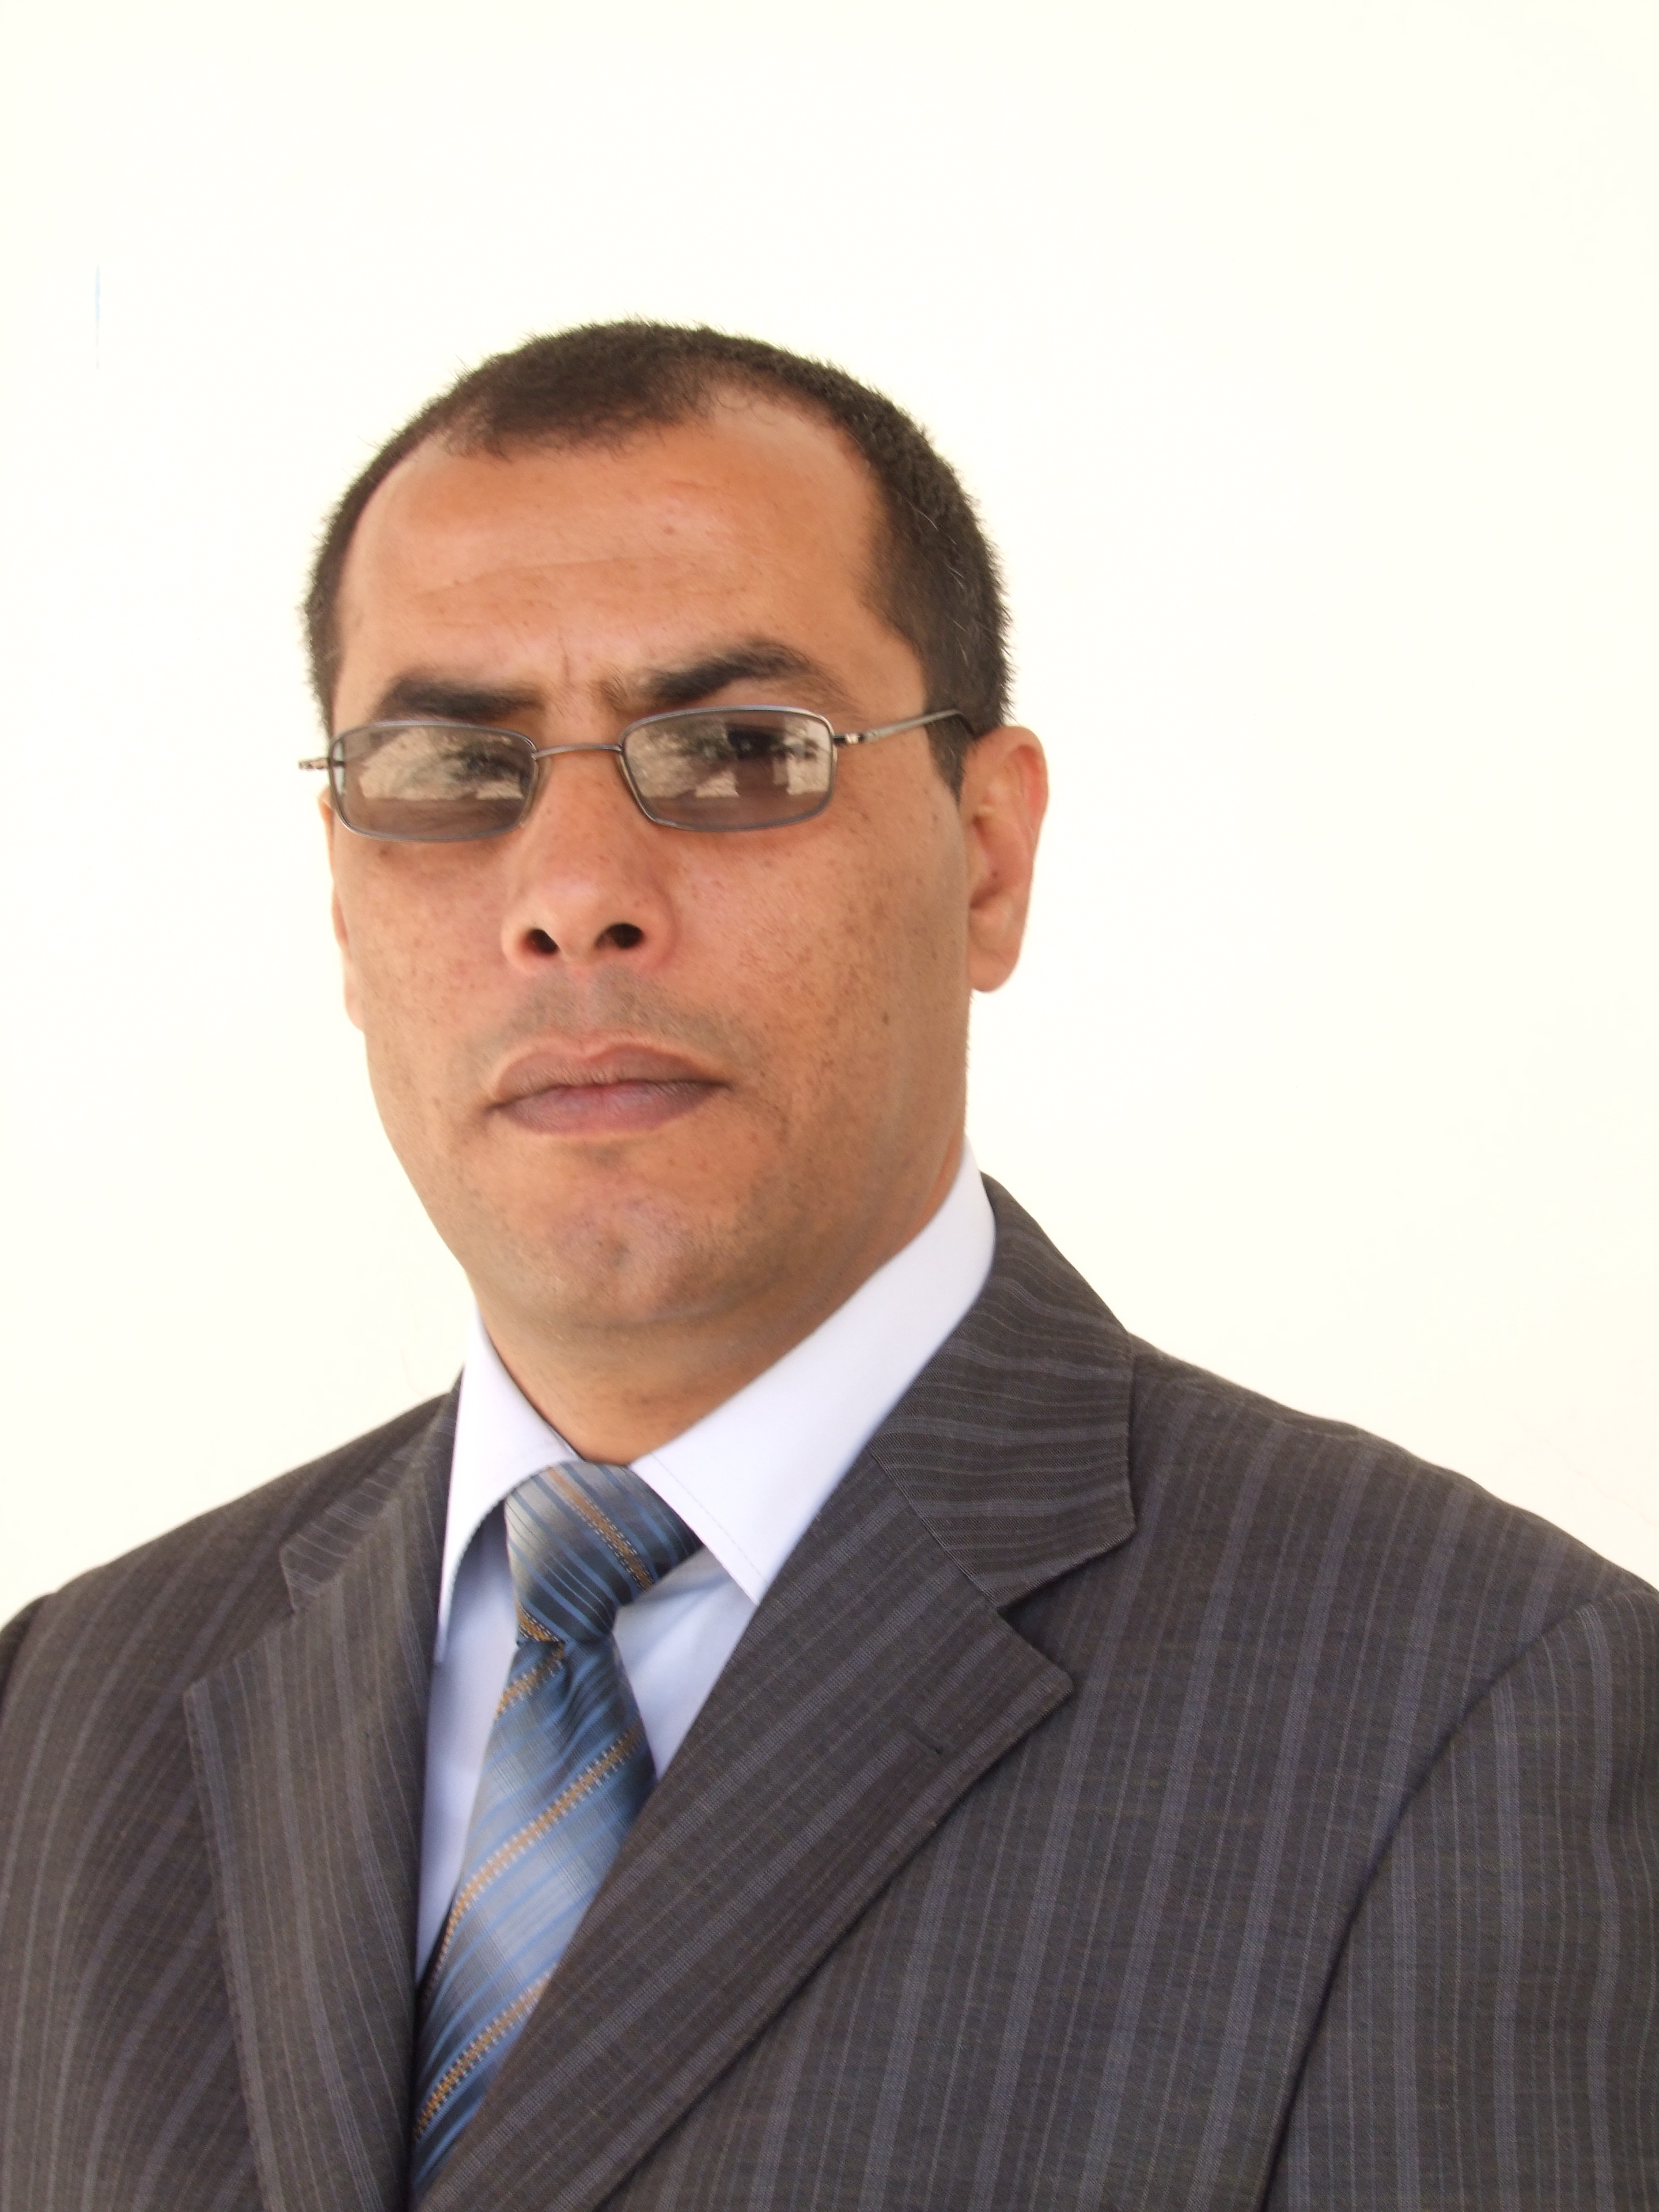
Hamed Saqer Al-Bdour
Professor

Mobile Number: +962-79-6717777 E-mail: h.bdour@ju.edu.jo

Personal Information
 | Date of Birth  Place of Birth  Nationality  Marital Status | :May 1, 1969  :Tafila, Jordan  :Jordanian  :Married , four children
Education
1993-1997 | PhD  Department of Computer Engineering, National Technical University of Ukraine (KPI)  PhD. Theses Title: Ways and means of optimization load in corporate computer networks
1987-1993 | Master of Technical Sciences  Department of Computer Engineering, National Technical University of Ukraine (KPI)
Academic Status
2014-2015 | Professor/Information Technology Department/ Mu`tah University
2013- 2014 | Professor/Faculty of Information Technology and Systems/ The University of Jordan/Aqaba Branch
2012- 2013 | Professor/ Faculty of Information Technology/ Umm Al-Qurqa University Sabbatical Leave
2011- 2012 | Professor/Information Technology Department/ Mu`tah University
2009- 2011 | Associate Professor/Information Technology Department/ Mu`tah University
2007-2009 | Associate Professor/ Faculty of Information Technology/ Applied Science Univ. Sabbatical Leave
2005–2007 | Associate Professor/ Information Technology Department/ Mu`tah University.
1999–2005 | Assistant Professor/ Information Technology Department/ Mu`tah University.
Professional Experience
2013- 2014 | Assistant President/ The University of Jordan/Aqaba Branch
2013- 2014 | Dean/Faculty of Information Technology and Systems/ The University of Jordan/Aqaba Branch
2010- 2011 | Vice Dean/ Faculty of Science/ Mu’tah University
2009- 2010 | Academic Coordinator/ Military Wing
2004– 2007 | Head Of Information Technology Department/ Mu'tah University
2003–2004 | Assistant Dean / Faculty of Science/ Mu’tah University
Courses taught
Programming Languages ( C++, VB, Java , Pascal )
Digital Systems Design
Computer Architecture
Microprocessor and Assembly Language
Operating Systems
Computer Networks
E-Commerce
Web Design
Graduation Project
Committee Member/
Mu'tah University
 | Editorial Board, Mu’tah LilBuhuth wad-Dirasat, Natural and Applied Sciences
 | University Computerizing Committee
 | Head of Graduate Studies Committee/Faculty of Science
 | Department Members Appointment Committee, (head & member)
 | Quality Assurance Committee
 | Information Technology Strategy
 | Electronic transition committee
 | Computer Training Committee
 | ICT Committee for the evaluation of ICT Strategies in Higher Education
 | Faculty of Science Consulting Committee
 | Head of Student Penalty Council
 | MUCDL Training committee for University staff
 | E-Learning Committee
 | Student Election Committee, (several times)
 | Higher Education Accreditation Committee
 | And so many Committees in Mutah University
Committee Member/
Outside Mutah
 | Member of jury for promotion process, (5 times)
 | Member of many Committees for discussion of Master Thesis, (20 times)
 | Technical committee/ 3rd International Conference on Machine Learning and Computing (2011), Tafila Technical University
 | Technical committee/ 3rd International Conference on Mechanical and Electrical Technology ICMET 2011, Tafila Technical University
 | The 3rd International Conference on Emerging Ubiquitous Systems and Pervasive Networks (EUSPN), Tafila Technical University
 | Quality Assurance Committee, Applied Science University
 | Faculty of Information Technology Consulting Committee, Applied Science University
 | Member Student Penalty Council, Applied Science University
Research Interest
 | Computer Architectures, Computer Networks, Mobile Networks, Operating Systems, Network Security.
Language Skills
 | Arabic | Native
 | English | Very good
 | Russian | Excellent
Membership
Member of Jordan Engineers Association (JEA), Jordan
Member of International Association of Computer Science and Information Technology (IACSIT)
 | Under review papers
 | Secure Information Transfer Based on Multipath Routing
 | Hierarchical Scheduling method for GRID Systems
 | Increasing the Efficiency of Data Exchange in Multiprocessor Systems
 | Hierarchical Security Agents in Distributed Computing Systems
References
 | Professor Ekhleif Tarawneh, President of the University of Jordan/ Jordan, E-Mail: c-Tarawneh@mohe.gov.jo, cliff@mutah.edu.jo
 | Professor Yacoub Masa'efah, President of Tafila Technical University, Tafila/ Jordan, E-Mail: yacoub111@yahoo.com
 | Baha Khasawneh, Associate Professor Head of Computer Graphics Department, Princes Sumaya University for Technology/Jordan, E-Mail: baha@psut.edu.jo

